CST 407 ML – Assignment 1 part 1 – Dev Env
Wilsonville, Summer 2022

Goal
Set up and verify your development environment.

Requirements
Follow these steps to complete this assignment…

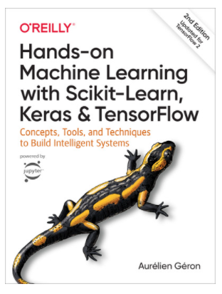
Step 1 – Open O’Reilly On-line Book
Hands-On Machine Learning with Sckit-Learn, Keras & TensorFlow, 2nd Edition
By Aurélien Géron
Copyright © 2019 Kiwisoft S.A.S.
ISBN 978-1-492-03264-9

You can access the book in the O’Reilly for Higher Education site, free from OIT:
- Open OIT’s TechWeb: https://techweb.oit.edu/
- Click the Libraries icon
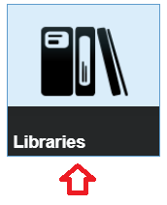
- Click the Electronic Resources link

- Click the ‘O’ link in the alphabetic index


- Find the “O’Reilly for Higher Education” listing and click the link
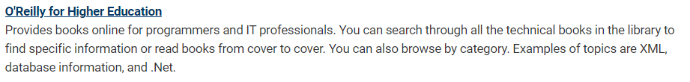
- Paste the book’s title in the “Search for books, videos, live events, and more” field and hit the Enter key

Step 2 – Install Development Environment
Follow directions in Chapter 2 “End-to-End Machine Learning Project” of the book, starting with the section “Get the Data” (pg 42 in a printed copy of the book)

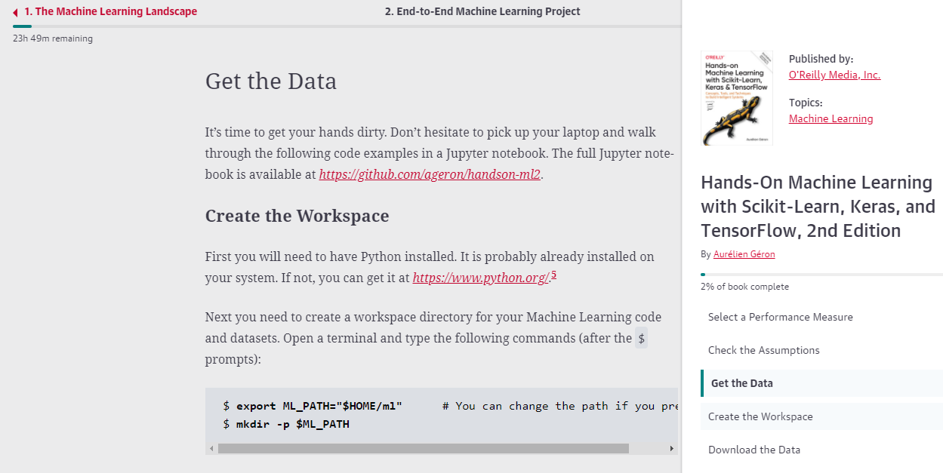

Note many of the instructions are specifically for Linux. If you are using Windows, you will need to use the command prompt and Windows friendly paths. For example…
“C:\CST407_ML\assign1”

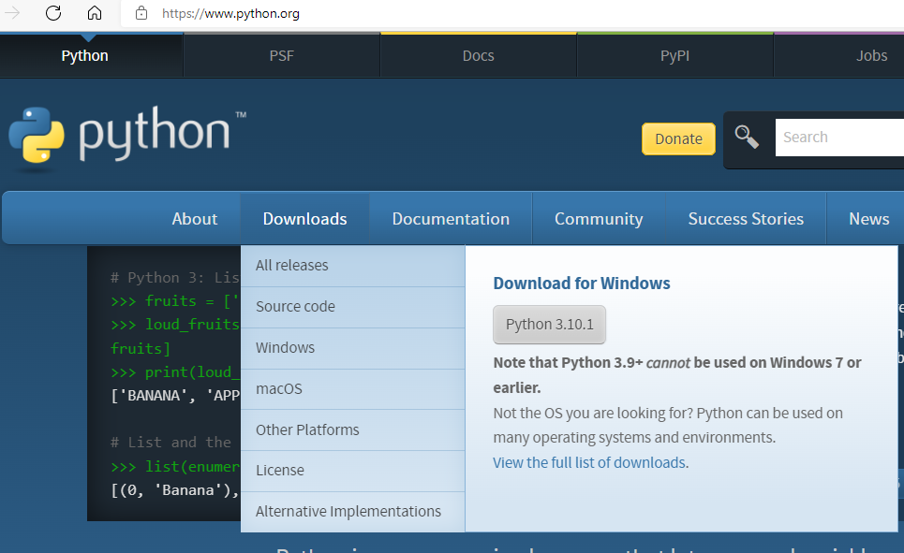
To install Python, go to www.python.org and download the latest version for your platform. For example…

Choose Add Python to PATH before clicking Install Now…
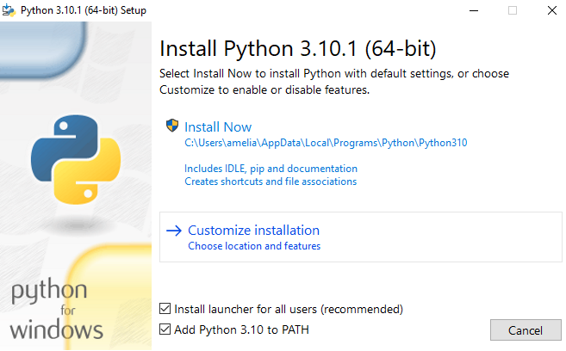

After installing Python, you should confirm that it is accessible in a command prompt, for example by verifying the version of PIP:

Note that the command “py” is used on Windows with Python v3.10.1, rather than “python3” as in the book.

The rest of the install steps can be followed from the book, including…
- Upgrade pip to the latest version
- Install virtualenv
- Create isolated Python environment “my_env”
- Activate my_env
- Install machine learning Python modules
- Register Python kernel for Jupyter
- Start Jupyter Notebook server
- Create a new, empty notebook
- Verify Jupyter works by printing “Hello, World!”

CRITICAL: From this point forward, whenever you’re done, click Logout in Jupyter, use Ctrl-C to stop the Jupyter notebook in your command prompt and then use the “deactivate” command to exit your virtual env. When you want to start again, run “activate” in your my_env bin or scripts folder and then “jupyter notebook” in your virtual env.

You should stop at this point in the book, right before the section “Download the Data”.

Step 3 – Test a Jupyter Notebook
- Download and unzip “CST 407ML - Assignment 1 part 1 Handout.zip” from Canvas, and copy assign1_part1.ipynb to your assign1 folder.
- Open your assign1_part1.ipynb in Jupyter Notebook
- Run each cell one at a time
- Follow the directions in the cell where it says “Your turn…”

Turn In
Turn in your assignment on Canvas, as a single Zip file including your Jupyter notebook and any supporting files that are not created/downloaded by your code. The instructor should be able to unzip your file, open your Jupyter notebook, and then run each cell.

Name your Zip file “CST407ML_Assign1_part1_<your name>.zip”. For example, if my name were Pete Myers, then I would turn in “CST407ML_Assign1_part1_PeteMyers.zip”.

Example Installation Steps for Windows
Following shows abbreviated output.
After installing Python 3.10 for Windows, open a command prompt and…

C:\CST407_ML\assign1>py -m pip --version
pip 21.2.4

C:\CST407_ML\assign1>py -m pip install --user -U pip
Successfully installed pip-21.3.1

C:\CST407_ML\assign1>py -m pip install --user -U pip
Requirement already satisfied

C:\CST407_ML\assign1>py -m pip install --user -U virtualenv
Successfully installed distlib-0.3.4 filelock-3.4.2 platformdirs-2.4.1 six-1.16.0 virtualenv-20.13.0

C:\CST407_ML\assign1>py -m virtualenv my_env

C:\CST407_ML\assign1>.\my_env\Scripts\activate

(my_env) C:\CST407_ML\assign1>py -m pip install -U jupyter matplotlib numpy pandas scipy scikit-learn
Successfully installed MarkupSafe-2.0.1 Send2Trash-1.8.0 argon2-cffi-21.3.0 argon2-cffi-bindings-21.2.0 attrs-21.4.0 backcall-0.2.0 bleach-4.1.0 cffi-1.15.0 colorama-0.4.4 cycler-0.11.0 debugpy-1.5.1 decorator-5.1.0 defusedxml-0.7.1 entrypoints-0.3 fonttools-4.28.5 ipykernel-6.6.1 ipython-7.30.1 ipython-genutils-0.2.0 ipywidgets-7.6.5 jedi-0.18.1 jinja2-3.0.3 joblib-1.1.0 jsonschema-4.3.3 jupyter-1.0.0 jupyter-client-7.1.0 jupyter-console-6.4.0 jupyter-core-4.9.1 jupyterlab-pygments-0.1.2 jupyterlab-widgets-1.0.2 kiwisolver-1.3.2 matplotlib-3.5.1 matplotlib-inline-0.1.3 mistune-0.8.4 nbclient-0.5.9 nbconvert-6.4.0 nbformat-5.1.3 nest-asyncio-1.5.4 notebook-6.4.6 numpy-1.22.0 packaging-21.3 pandas-1.3.5 pandocfilters-1.5.0 parso-0.8.3 pickleshare-0.7.5 pillow-9.0.0 prometheus-client-0.12.0 prompt-toolkit-3.0.24 pycparser-2.21 pygments-2.11.1 pyparsing-3.0.6 pyrsistent-0.18.0 python-dateutil-2.8.2 pytz-2021.3 pywin32-303 pywinpty-1.1.6 pyzmq-22.3.0 qtconsole-5.2.2 qtpy-2.0.0 scikit-learn-1.0.2 scipy-1.7.3 six-1.16.0 terminado-0.12.1 testpath-0.5.0 threadpoolctl-3.0.0 tornado-6.1 traitlets-5.1.1 wcwidth-0.2.5 webencodings-0.5.1 widgetsnbextension-3.5.2

(my_env) C:\CST407_ML\assign1>py -m ipykernel install --user --name=py
(my_env) C:\CST407_ML\assign1>jupyter notebook
Note: Your browser should appear with Jupyter Notebook running
Continue when done…
^C
(my_env) C:\CST407_ML\assign1>deactivate
C:\CST407_ML\assign1>

